Mini-Project duo group 7

Venkata Bapanapalli

Karthik Meyyappan

Contributions: Both members equally contributed to analytically solve and implement the code of the given two questions.1. Question 1:

1. The Monte Carlo Approach can be applied by Using a population parameter then simulating the samples which will calculate of the estimator value. The mean squared error is the estimated value of the difference squared amongst the estimator and parameter.
2. MSE(θ1) = 0.3382258, MSE(θ2) = 0.3376842
3. Part C:

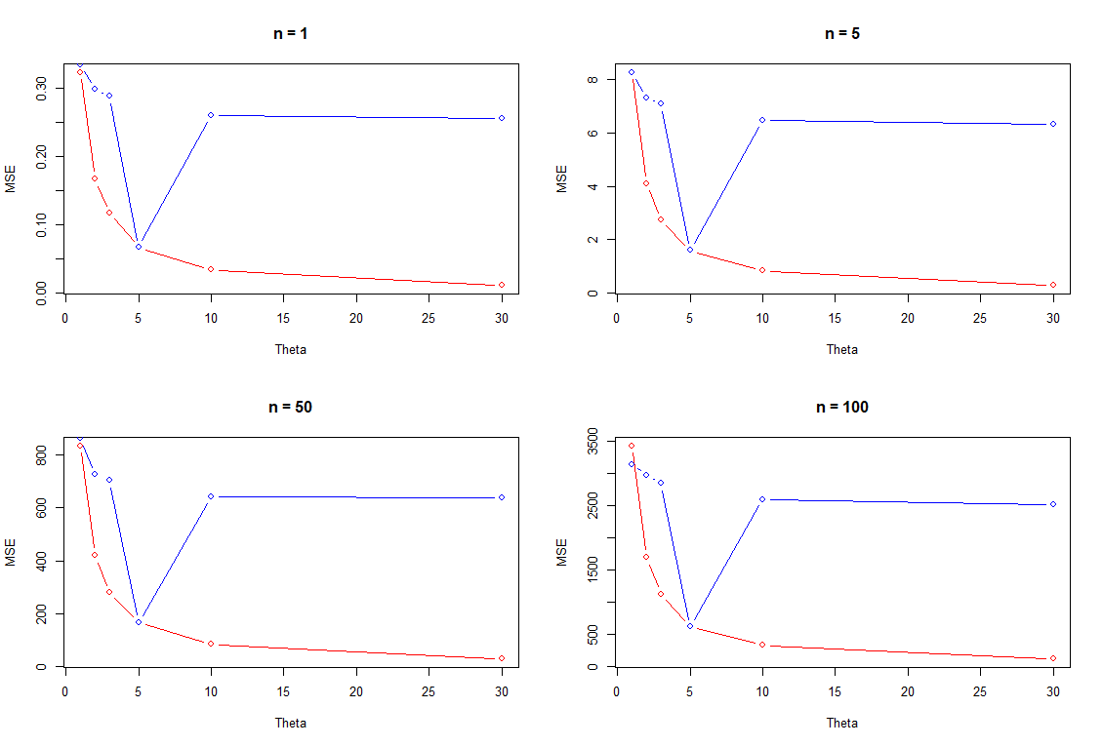Mean squared errors of MLE and MOM, n with fixed θ:

Mean squared errors of MLE and MOM, θ with fixed n:

1. 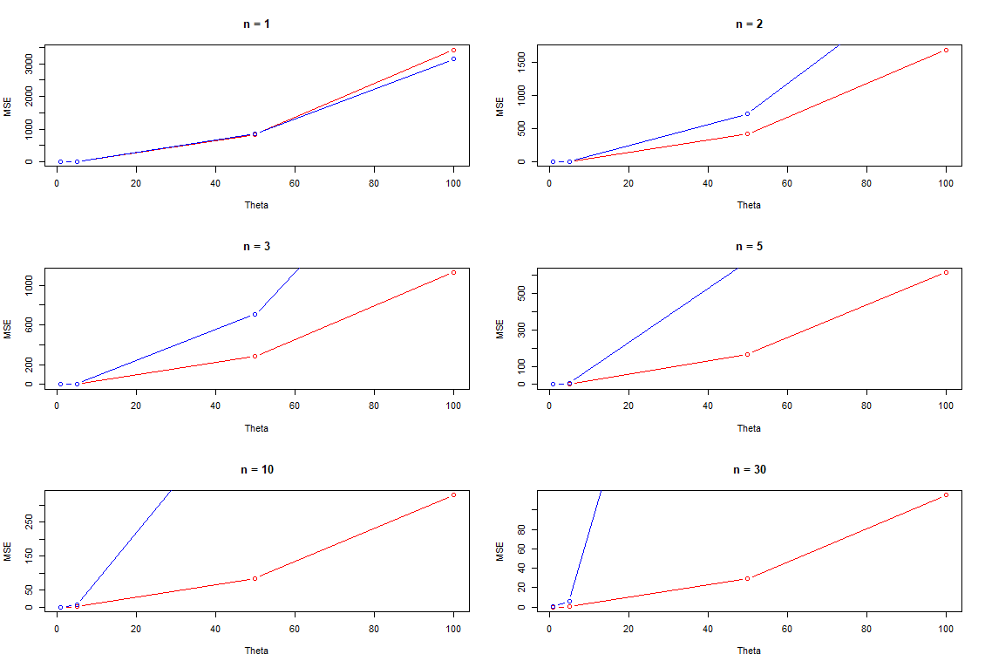It can be concluded that set 1 with fixed θ and varying n results in similar graphs. Hence, we can also say that estimator doesn’t depend on the value of n. The second graph set plotted values of mean squared errors varying with n and fixed θ. We can use the Method of Moment Estimator for small values of n for 3 and under and the for the values higher than 3 the maximum likelihood estimator is better. MLE is preferred since the mean squared error is less compared to that of Method of Moments.

2. Question 2:

1. Take likelihood function as $L\left(θ\right)= \prod_{i=1}^{n}{\left(\frac{θ}{x_{i}^{θ+1}}\right)}$

$$\log\left(L\left(θ\right)\right)=log⁡(\prod_{i=1}^{n}{\left(\frac{θ}{x_{i}^{θ+1}}\right)}$$

$$=log⁡(θ^{n}*\prod_{i=1}^{n}{\left(\frac{1}{x_{i}^{θ+1}}\right))}$$

$$=nlogθ+ \sum_{i=1}^{n}{\log\left(x_{i}^{-θ-1}\right)}$$

$$=nlogθ-(θ+1)\sum_{i=1}^{n}{\log{x_{i}}}$$

$=nlogθ- θ \sum_{i=1}^{n}{\log{x_{i}}}-\sum_{i=1}^{n}{\log{x_{i}}}$

Partially differentiated:

$= \frac{n}{θ}- \sum_{i=1}^{n}{\log{x_{i}}}$

Once the equation is equated to 0:

$\frac{n}{θ}- \sum_{i=1}^{n}{\log{x_{i}=0}}$

$$\frac{n}{θ}= \sum_{i=1}^{n}{\log{x_{i}}}$$

$${\hat{θ}}_{MLE}= \frac{n}{\sum_{i=1}^{n}{\log{x_{i}}}}$$

1. Values need to be plugged into the equation. Resulting answer is:
$${\hat{θ}}_{MLE}=\frac{5}{\log\left(21.72\right)+\log\left(14.65\right)+\log\left(50.42\right)+\log\left(28.78\right)+\log\left(11.23\right)}$$

$${\hat{θ}}_{MLE}= \frac{5}{log⁡(5137517.08)}=\frac{5}{15.45}=0.3236$$

2. R allows us to provision to minimize a given function. In this scenario we require maximization to occur. Negating a function leads to maximization, so that is why the function gets negated and then minimized in R. Estimate is 0.3236.
3. To determine the true estimate value, we know that it must lie in the 95% interval out of 100 trials to get an accurate population estimate.

From the code we can determine the Standard error value to be 0.144752